Q1: What is a Random Forest?
Q2: Why do we need the random forest algorithm?
Q3: What are the advantages of the random forest methodology?
Q4: What are the disadvantages of the random forest methodology?
Q5: How do random forests maintain accuracy when data is missing?
Q6: What do you mean by Bootstrap Sample?
Q7: What does random refer to in ‘Random Forest’?
Q8: How does a Random Forest Algorithm give predictions on an unseen dataset?
Q9: Explain the working of the Random Forest Algorithm.
Q10: What is Out-of-Bag Error?

Answers:
- Random forest is an ensemble machine learning technique that averages several decision trees on different parts of the same training set, with the objective of overcoming the overfitting problem of the individual decision trees.
In other words, a random forest algorithm is used for both classification and regression problem statements that operate by constructing a lot of decision trees at training time.
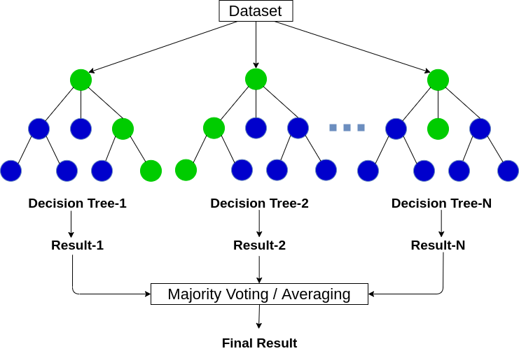

2. A random forest can be used for either classification or regressions tasks whilst producing results with greater accuracy as it employs cross-validation. It even handles any incomplete values and can handle a more extensive data set with many features (dimensions). Most importantly, it does all this with reduced over-fitting since it chooses random features and generalizes well over the given data. That makes it a much more accurate and hence better algorithm than the usual decision tree method, which lacks most of the qualities mentioned above.
3. The advantages of using the random forest algorithm are as follows:
- Random forest reduces the problem of overfitting by averaging or combining the outputs of several decision trees.
- From the above, it can be seen that they work well for an extensive data set compared to a single decision tree. It, therefore, has less variance as compared to a decision tree.
- Random forests exhibit flexibility and are very highly accurate.
- When it comes to using the random forest algorithm, there is no requirement of scaling the data as it establishes a good accuracy either way.
- Even when a lot of data is missing, the random forest method shows excellent accuracy.
- It is unbiased as we train multiple decision trees and each tree is trained on a subset of the same training data.
- It is very stable since if we introduce the new data points in the dataset, then it does not affect much as the new data point impacts one tree, and is pretty hard to impact all the trees.
- Also, it works well when you have both categorical and numerical features in the problem statement.

4. The disadvantages of the random forest method are as stated below:
- It’s pretty complex compared to other methods. Hence, complexity is the major disadvantage of this algorithm.
- More time is consumed during the construction of the various decision trees in a random forest algorithm.
- Due to the above, greater computational power is required to implement a random forest algorithm.
- Its intuitiveness sees a drop once the number of decision trees is greater.
- Due to their complexity, training time is more compared to other algorithms.

5. They do this by usually be making use of two methods:
- Dropping/removing the data points where values are not present but is not a preferred method since the available information is not being made use of.
- By filling in/completing the missing values with median if the values are numerical, and mode if the values are categorical. However, even this has its drawbacks since sometimes the accurate picture cannot be depicted if a lot of the data is missing.

6. It is basically random with the replacement sampling method.
For Example, Suppose we have a box of lottery tickets in which there are 100 unique numbers from 0 to 99. We want to select a random sample of tickets from the box. If we put the ticket back in the box, it may be selected more than once. Therefore, in this process, we are picking the samples randomly from the box with replacement.
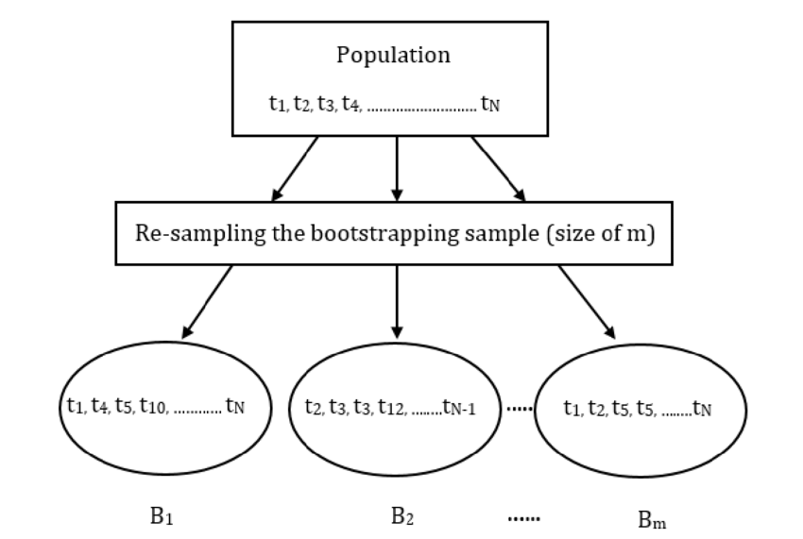
7. ‘Random’ in Random Forest refers to mainly two processes –
- Random observations to grow each tree.
- Random variables selected for splitting at each node.
Random Record Selection: Each tree in the forest is trained on roughly 2/3rd of the total training data (exactly 63.2%) and here the data points are drawn at random with replacement from the original training dataset. This sample will act as the training set for growing the tree.
Random Variable Selection: Some independent variables(predictors) say, m are selected at random out of all the predictor variables, and the best split on this m is used to split the node.
NOTE:
- By default, m is taken as the square root of the total number of predictors for classification whereas m is the total number of all predictors divided by 3 for regression problems.
- The value of m remains constant during the algorithm run i.e, forest growing.

8. After training the algorithm, each tree in the forest gives a classification on leftover data (OOB), and we say the tree “votes” for that class. Then finally, the forest chooses the classification having the most votes over all the trees in the forest.
For a binary dependent variable, the vote will be either YES or NO, and finally, it will count up the YES votes. This is the Random Forest (RF) score and the percent YES votes received is the predicted probability. In the regression case, it is the average of the dependent variable.
For example, suppose we fit 500 trees in a forest, and a case is out-of-bag in 200 of them:
- 160 trees vote class 1
- 40 trees vote class 2
In this case, the RF score is class1 since the probability for that case would be 0.8 which is 160/200. Similarly, it would be an average of the target variable for the regression problem.

9. The steps that are included while performing the random forest algorithm are as follows:
Step-1: Pick K random records from the dataset having a total of N records.
Step-2: Build and train a decision tree model on these K records.
Step-3: Choose the number of trees you want in your algorithm and repeat steps 1 and 2.
Step-4: In the case of a regression problem, for an unseen data point, each tree in the forest predicts a value for output. The final value can be calculated by taking the mean or average of all the values predicted by all the trees in the forest.
and, in the case of a classification problem, each tree in the forest predicts the class to which the new data point belongs. Finally, the new data point is assigned to the class that has the maximum votes among them i.e, wins the majority vote.

10. Out-of-Bag is equivalent to validation or test data. In random forests, there is no need for a separate testing dataset to validate the result. It is calculated internally, during the algorithm run, in the following manner –
As the forest is built on training data, each tree is tested on 1/3rd of the samples (36.8%) that are not used in building that tree (similar to the validation data set).
This is known as the out-of-bag error estimate which in short is an internal error estimate of a random forest as it is being constructed.

